# UI Design Requirements

## Client: Acme Insurance Company

Document Prepared by:

## Requirements brief

* Create a CRUD app that works with an existing database. Ensure that referential integrity is not compromised.
* Screens for user interaction will be lumped into Categories, Customers, Products, ProductTypes and Sales.
* Each of these will require a display of the existing information and a way to create, update and delete additional records.
* For special cases (Customers, Products and Sales) a search filter must be built in.
* The main form should include a dashboard displaying Products, Product types and the number of sales for each product.

## Application content flow diagram

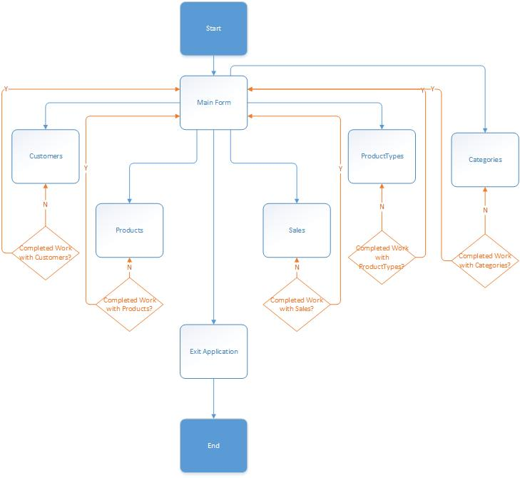

Figure : Content flow from Main to Data Sections

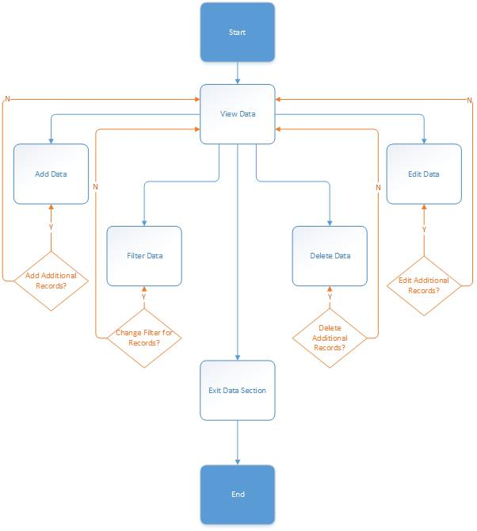

Figure : Content Flow within Data Section

## Images of the Prototypes developed

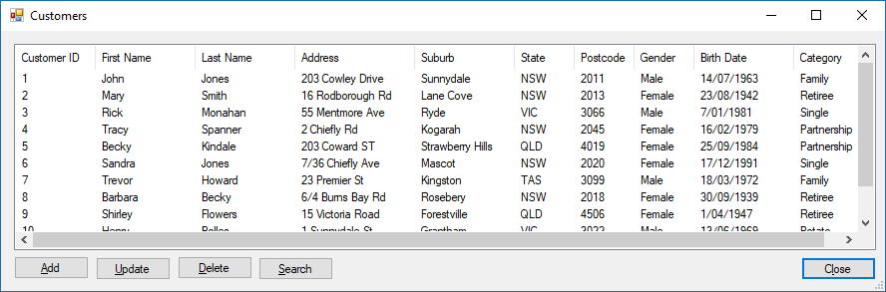

Figure : Customers View Screen

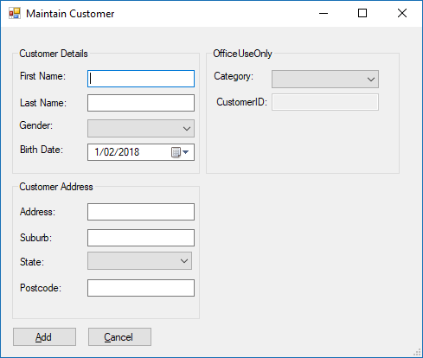

Figure : Maintain Customer Screen

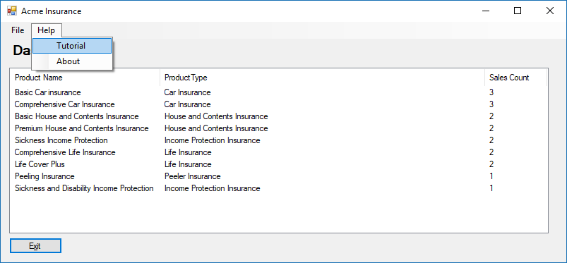

Figure : Main Screen - Help Menu

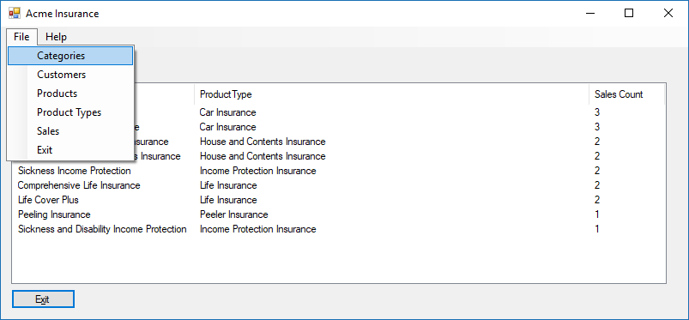

Figure : Main Screen - File Menu

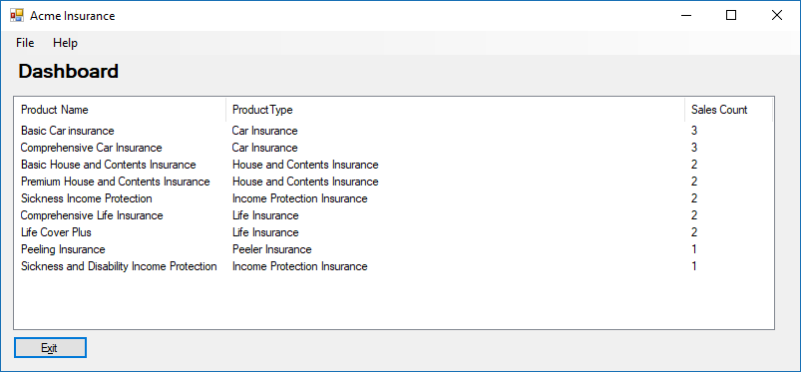

Figure : Main Screen - Dashboard

## Changes suggested by the client.

## Form Designs

### Form Name: Main

### Form Description: Main Screen

### Form:

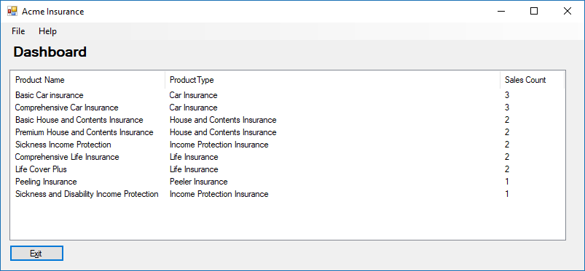

### Form Components

|  |  |  |  |  |
| --- | --- | --- | --- | --- |
| No. | Column Names | Control | Property | Value |
| 1. | mnsMain | MenuStrip |  |  |
| 2. | exitToolStripMenuItem | ToolStripMenuItem | Text | Exit |
| 3. | btnExit | Button | Text | E&xit |
| 4. | customersToolStripMenuItem | ToolStripMenuItem | Text | Customers |
| 5. | productsToolStripMenuItem | ToolStripMenuItem | Text | Products |
| 6 | categoriesToolStripMenuItem | ToolStripMenuItem | Text | Categories |
| 7 | productTypesToolStripMenuItem | ToolStripMenuItem | Text | Product Types |
| 8 | salesToolStripMenuItem | ToolStripMenuItem | Text | Sales |
| 9 | tutorialToolStripMenuItem | ToolStripMenuItem | Text | Tutorial |
| 10 | aboutToolStripMenuItem | ToolStripMenuItem | Text | About |
| 11 | lblDashboard | Label | Text | Dashboard |

### Events Used on the form.

|  |  |  |
| --- | --- | --- |
| Component Name | Event | Description |
| exitToolStripMenuItem | Click | Exit Application |
| btnExit | Click | Exit Application |
| customersToolStripMenuItem | Click | Show Customers View |
| productsToolStripMenuItem | Click | Show Products View |
| categoriesToolStripMenuItem | Click | Show Categories View |
| productTypesToolStripMenuItem | Click | Show Product Types View |
| salesToolStripMenuItem | Click | Show Sales View |
| frmMain | Load | Load the main page – Display Dashboard |
| tutorialToolStripMenuItem | Click | Open Tutorial Webpage |
| aboutToolStripMenuItem | Click | Show About form |

### Form Name: About

### Form Description: About Screen

### Form:

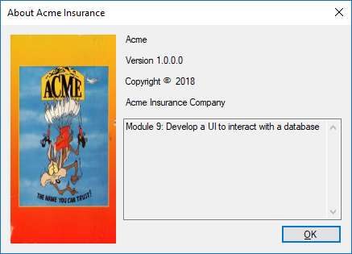

### Form Components

|  |  |  |  |  |
| --- | --- | --- | --- | --- |
| No. | Column Names | Control | Property | Value |
| 1. | labelProductName | Label | Text | Product Name |
| 2. | labelVersion | Label | Text | Version |
| 3. | labelCopyright | Label | Text | Copyright |
| 4. | labelCompanyName | Label | Text | CompanyName |
| 5. | textBoxDescription | TextBox | Text | Description |
| 6 | textBoxDescription | TextBox | Multiline | True |
| 7 | logoPictureBox | PictureBox | Image | System.Drawing.Bitmap(Acme Logo) |
| 8 | logoPictureBox | PictureBox | InitalImage | System.Drawing.Bitmap(Acme Logo) |
| 9 | okButton | Button | Text | &Ok |
| 10 |  |  | Text |  |
| 11 |  |  | Text |  |

### Events Used on the form.

|  |  |  |
| --- | --- | --- |
| Component Name | Event | Description |
| frmAbout | Creation | Load information from the assemblies |

### Form Name: frmCategoriesMaintenance

### Form Description: Categories Maintenance Screen

### Form:

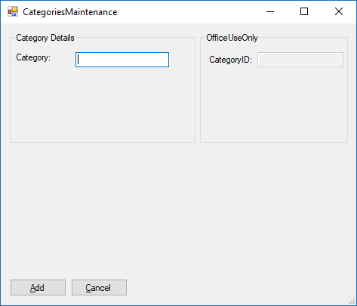

### Form Components

|  |  |  |  |  |
| --- | --- | --- | --- | --- |
| No. | Column Names | Control | Property | Value |
| 1. | grpCategoryDetails | Group Box | Text | Category Details |
| 2. | lblCategory | Label | Text | Category |
| 3. | txtCategory | Textbox |  |  |
| 4. | grpOfficeUseOnly | Label | Text | Office Use Only |
| 2. | lblCategoryID | Label | Text | CategoryID |
| 3. | txtCategoryID | Textbox |  |  |
| 5. | btnAdd | Button | Text | &Add |
| 6 | btnCancel | Button | Text | &Cancel |

### Events Used on the form.

|  |  |  |
| --- | --- | --- |
| Component Name | Event | Description |
| btnCancel | Click | Close Screen |
| CategoriesMaintenance | Load | Load information (if applicable) |
| BtnAdd | Click | Validate and Add to database |

### Form Name: frmCategoriesView

### Form Description: Categories View Screen

### Form:

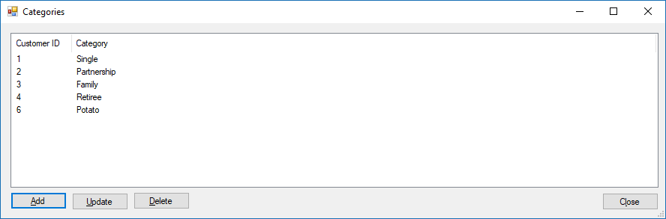

### Form Components

|  |  |  |  |  |
| --- | --- | --- | --- | --- |
| No. | Column Names | Control | Property | Value |
| 1. | btnClose | Button | Text | C&lose |
| 2. | lvCategories | ListView | ColumnHeader | categoryID |
| 3. | lvCategories | ListView | ColumnHeader | category |
| 4. | btnAdd | Button | Text | &Add |
| 2. | btnUpdate | Button | Text | &Update |
| 3. | btnDelete | Button |  | &Delete |

### Events Used on the form.

|  |  |  |
| --- | --- | --- |
| Component Name | Event | Description |
| btnAdd | Click | Show Maintenance Screen |
| btnUpdate | Click | Show Maintenance Screen |
| btnDelete | Click | Validate and delete record |

### Form Name: frmCustomersMaintenance

### Form Description: Customers Maintenance Screen

### Form:

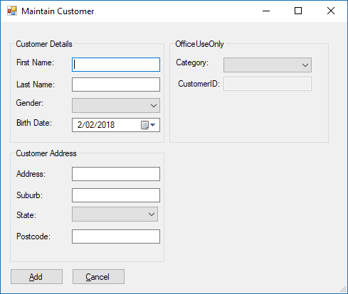

### Form Components

|  |  |  |  |  |
| --- | --- | --- | --- | --- |
| No. | Column Names | Control | Property | Value |
| 1. | grpCustomerDetails | Group Box | Text | Customer Details |
| 2. | lblFirstName | Label | Text | First Name: |
| 3. | txtFirstName | Textbox |  |  |
| 4. | lblLastName | Label | Text | Last Name: |
| 5. | txtLastName | Textbox |  |  |
| 6. | lblAddress | Label | Text | Address: |
| 7. | txtAddress | Textbox |  |  |
| 8. | lblSuburb | Label | Text | Suburb: |
| 9. | txtSuburb | Textbox |  |  |
| 10. | lblPostcode | Label | Text | Postcode: |
| 11. | txtPostcode | Textbox |  |  |
| 10. | lblGender | Label | Text | Gender: |
| 11. | cmbGender | ComboBox | Dropdown Style | Drop Down List |
| 10. | lblBirthDate | Label | Text | Birth Date: |
| 11. | dtpBirthDate | Date Time | Format | Short |
| 10. | lblState | Label | Text | State |
| 11. | cmbState | ComboBox | Dropdown Style | Drop Down List |
| 10. | lblCategory | Label | Text | Category: |
| 11. | cmbCategory | ComboBox | Dropdown Style | Drop Down List |
| 12. | grpAddress | Label | Text | Customer Address |
| 13. | grpOfficeUseOnly | Label | Text | Office Use Only |
| 14. | lblCustomerID | Label | Text | CustomerID: |
| 15. | txtCustomerID | Textbox |  |  |
| 16. | btnAdd | Button | Text | &Add |
| 17 | btnCancel | Button | Text | &Cancel |

### Events Used on the form.

|  |  |  |
| --- | --- | --- |
| Component Name | Event | Description |
| btnCancel | Click | Close Screen |
| CustomersMaintenance | Load | Load information (if applicable) |
| BtnAdd | Click | Validate and Add to database |

### Form Name: frmCustomersView

### Form Description: Customers View Screen

### Form:

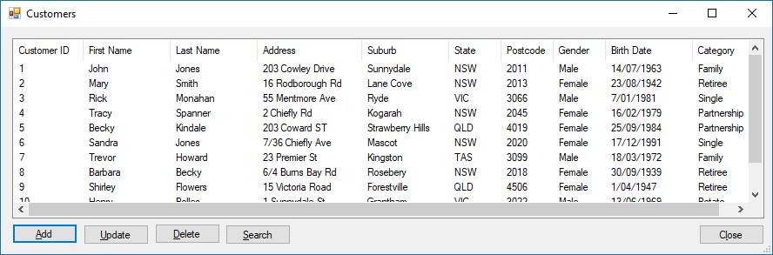

### Form Components

|  |  |  |  |  |
| --- | --- | --- | --- | --- |
| No. | Column Names | Control | Property | Value |
| 1 | btnClose | Button | Text | C&lose |
| 2 | lvCustomers | ListView | ColumnHeader | CustomerID |
| 3 | lvCustomers | ListView | ColumnHeader | Customer |
| 4 | lvCustomers | ListView | ColumnHeader | customerID |
| 5 | lvCustomers | ListView | ColumnHeader | category |
| 6 | lvCustomers | ListView | ColumnHeader | firstName |
| 7 | lvCustomers | ListView | ColumnHeader | lastName |
| 8 | lvCustomers | ListView | ColumnHeader | address |
| 9 | lvCustomers | ListView | ColumnHeader | suburb |
| 10 | lvCustomers | ListView | ColumnHeader | state |
| 11 | lvCustomers | ListView | ColumnHeader | postcode |
| 12 | lvCustomers | ListView | ColumnHeader | gender |
| 13 | lvCustomers | ListView | ColumnHeader | birthDate |
| 14 | btnAdd | Button | Text | &Add |
| 15 | btnUpdate | Button | Text | &Update |
| 16 | btnDelete | Button | Text | &Delete |
| 16 | btnSearch | Button | Text | &Search |

### Events Used on the form.

|  |  |  |
| --- | --- | --- |
| Component Name | Event | Description |
| btnAdd | Click | Show Maintenance Screen |
| btnUpdate | Click | Show Maintenance Screen |
| btnDelete | Click | Validate and delete record |
| btnSearch | Click | Open Search Screen |
| btnClose | Click | Close View Screen |

### Form Name: frmCustomersSearch

### Form Description: Customers Search Screen

### Form:

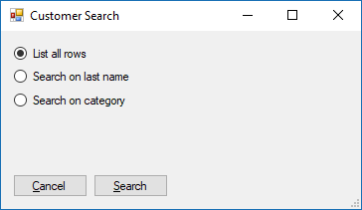

### Form Components

|  |  |  |  |  |
| --- | --- | --- | --- | --- |
| No. | Column Names | Control | Property | Value |
| 1 | rdoAll | RadioButton | Text | List all rows |
| 2 | rdoLastName | RadioButton | Text | Search on Last Name |
| 3 | rdoCategory | RadioButton | Text | Search on Category |
| 4 | txtSearch | TextBox |  |  |
| 5 | cmbCategory | ComboBox |  |  |
| 7 | btnSearch | Button | Text | &Search: |
| 8 | btnCancel | Button | Text | &Cancel: |

### Events Used on the form.

|  |  |  |
| --- | --- | --- |
| Component Name | Event | Description |
| btnCancel | Click | Cancel Search attempt |
| btnSearch | Click | Set search and return to list View |
|  |  |  |

### Form Name: frmProductsMaintenance

### Form Description: Products Maintenance Screen

### Form:

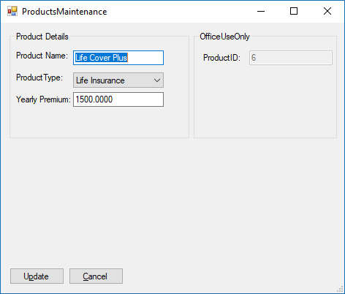

### Form Components

|  |  |  |  |  |
| --- | --- | --- | --- | --- |
| No. | Column Names | Control | Property | Value |
| 1. | grpProductDetails | Group Box | Text | Product Details |
| 2. | lblProductName | Label | Text | Product Name: |
| 3. | txtProductName | Textbox |  |  |
| 4. | lblYearlyPremium | Label | Text | Yearly Premium: |
| 5. | txtYearlyPremium | Textbox |  |  |
| 10. | lblProductType | Label | Text | Product Type: |
| 11. | cmbProductType | ComboBox | Dropdown Style | Drop Down List |
| 13. | grpOfficeUseOnly | Label | Text | Office Use Only |
| 14. | lblProductID | Label | Text | Product ID: |
| 15. | txtProductID | Textbox |  |  |
| 16. | btnAdd | Button | Text | &Add |
| 17 | btnCancel | Button | Text | &Cancel |

### Events Used on the form.

|  |  |  |
| --- | --- | --- |
| Component Name | Event | Description |
| btnCancel | Click | Close Screen |
| ProductsMaintenance | Load | Load information (if applicable) |
| BtnAdd | Click | Validate and Add to database |

### Form Name: frmProductTypesMaintenance

### Form Description: Product Types Maintenance Screen

### Form:

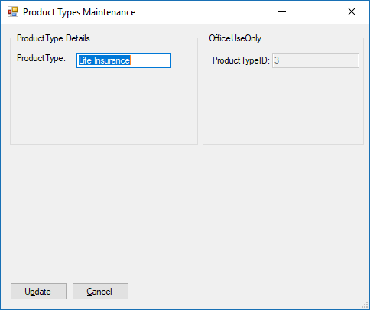

### Form Components

|  |  |  |  |  |
| --- | --- | --- | --- | --- |
| No. | Column Names | Control | Property | Value |
| 1. | grpProductTypeDetails | Group Box | Text | Product Type Details |
| 2. | lblProductType | Label | Text | Product Type: |
| 3. | txtProductType | Textbox |  |  |
| 4 | grpOfficeUseOnly | Label | Text | Office Use Only |
| 5 | lblProductTypeID | Label | Text | ProductType ID: |
| 6. | txtProductTypeID | Textbox |  |  |
| 7. | btnAdd | Button | Text | &Add |
| 8 | btnCancel | Button | Text | &Cancel |

### Events Used on the form.

|  |  |  |
| --- | --- | --- |
| Component Name | Event | Description |
| btnCancel | Click | Close Screen |
| ProductTypesMaintenance | Load | Load information (if applicable) |
| BtnAdd | Click | Validate and Add to database |

### Form Name: frmSalesMaintenance

### Form Description: Product Types Maintenance Screen

### Form:

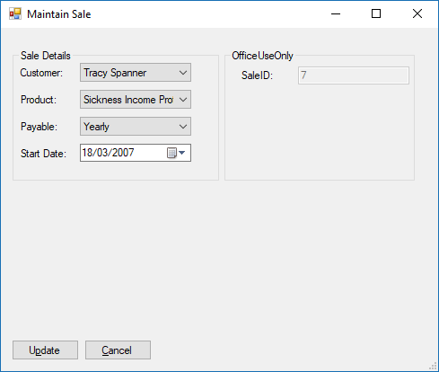

### Form Components

|  |  |  |  |  |
| --- | --- | --- | --- | --- |
| No. | Column Names | Control | Property | Value |
| 1. | grpSalesDetails | Group Box | Text | Product Type Details |
| 10. | lblCustomer | Label | Text | Customer: |
| 11. | cmbCustomer | ComboBox | Dropdown Style | Drop Down List |
| 10. | lblProduct | Label | Text | Product: |
| 11. | cmbProduct | ComboBox | Dropdown Style | Drop Down List |
| 10. | lblPayable | Label | Text | Payable: |
| 11. | cmbPayable | ComboBox | Dropdown Style | Drop Down List |
| 10. | lblStartDate | Label | Text | Start Date |
| 11. | dtpStartDate | Date Time | Format | Short |
| 4 | grpOfficeUseOnly | Label | Text | Office Use Only |
| 5 | lblSalesID | Label | Text | SalesID |
| 6. | txtSalesID | Textbox |  |  |
| 7. | btnAdd | Button | Text | &Add |
| 8 | btnCancel | Button | Text | &Cancel |

### Events Used on the form.

|  |  |  |
| --- | --- | --- |
| Component Name | Event | Description |
| btnCancel | Click | Close Screen |
| SalessMaintenance | Load | Load information (if applicable) |
| BtnAdd | Click | Validate and Add to database |

### Form Name: frmProductsView

### Form Description: Products View Screen

### Form:

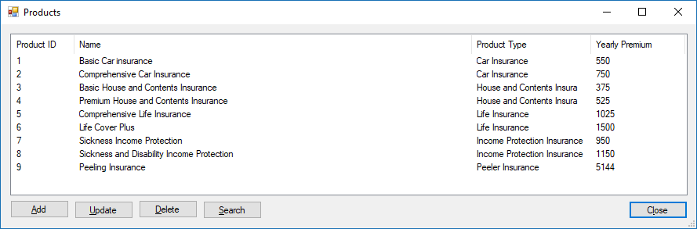

### Form Components

|  |  |  |  |  |
| --- | --- | --- | --- | --- |
| No. | Column Names | Control | Property | Value |
| 1 | btnClose | Button | Text | C&lose |
| 2 | lvProducts | ListView | ColumnHeader | ProductID |
| 3 | lvProducts | ListView | ColumnHeader | Product |
| 4 | lvProducts | ListView | ColumnHeader | productID; |
| 5 | lvProducts | ListView | ColumnHeader | productType; |
| 6 | lvProducts | ListView | ColumnHeader | productName; |
| 7 | lvProducts | ListView | ColumnHeader | yearlyPremium; |
| 14 | btnAdd | Button | Text | &Add |
| 15 | btnUpdate | Button | Text | &Update |
| 16 | btnDelete | Button | Text | &Delete |
| 16 | btnSearch | Button | Text | &Search |

### Events Used on the form.

|  |  |  |
| --- | --- | --- |
| Component Name | Event | Description |
| btnAdd | Click | Show Maintenance Screen |
| btnUpdate | Click | Show Maintenance Screen |
| btnDelete | Click | Validate and delete record |
| btnSearch | Click | Open Search Screen |
| btnClose | Click | Close View Screen |

### Form Name: frmSalesView

### Form Description: Sales View Screen

### Form:

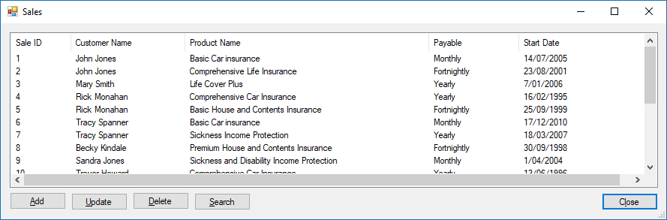

### Form Components

|  |  |  |  |  |
| --- | --- | --- | --- | --- |
| No. | Column Names | Control | Property | Value |
| 1 | btnClose | Button | Text | C&lose |
| 2 | lvSales | ListView | ColumnHeader | SaleID |
| 3 | lvSales | ListView | ColumnHeader | Sale |
| 4 | lvSales | ListView | ColumnHeader | SaleID |
| 5 | lvSales | ListView | ColumnHeader | customerName |
| 6 | lvSales | ListView | ColumnHeader | productName |
| 7 | lvSales | ListView | ColumnHeader | payable |
| 7 | lvSales | ListView | ColumnHeader | startDate |
| 14 | btnAdd | Button | Text | &Add |
| 15 | btnUpdate | Button | Text | &Update |
| 16 | btnDelete | Button | Text | &Delete |
| 16 | btnSearch | Button | Text | &Search |

### Events Used on the form.

|  |  |  |
| --- | --- | --- |
| Component Name | Event | Description |
| btnAdd | Click | Show Maintenance Screen |
| btnUpdate | Click | Show Maintenance Screen |
| btnDelete | Click | Validate and delete record |
| btnSearch | Click | Open Search Screen |
| btnClose | Click | Close View Screen |

### Form Name: frmProductTypesView

### Form Description: Product Types View Screen

### Form:

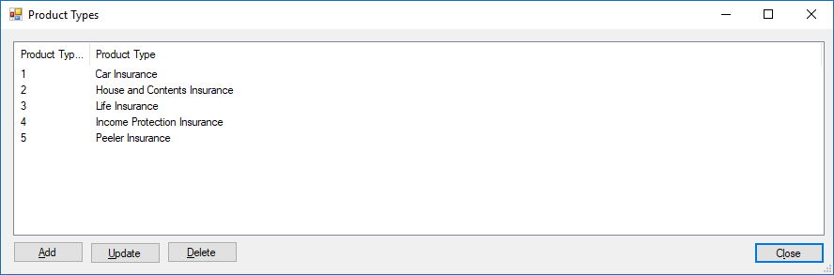

### Form Components

|  |  |  |  |  |
| --- | --- | --- | --- | --- |
| No. | Column Names | Control | Property | Value |
| 1 | btnClose | Button | Text | C&lose |
| 2 | lvProductTypes | ListView | ColumnHeader | ProductTypeID |
| 3 | lvProductTypes | ListView | ColumnHeader | ProductType |
| 4 | lvProductTypes | ListView |  |  |
| 5 | btnAdd | Button | Text | &Add |
| 6 | btnUpdate | Button | Text | &Update |
| 7 | btnDelete | Button | Text | &Delete |

### Events Used on the form.

|  |  |  |
| --- | --- | --- |
| Component Name | Event | Description |
| btnAdd | Click | Show Maintenance Screen |
| btnUpdate | Click | Show Maintenance Screen |
| btnDelete | Click | Validate and delete record |
| btnClose | Click | Close View Screen |

### Form Name: frmProductsSearch

### Form Description: Products Search Screen

### Form:

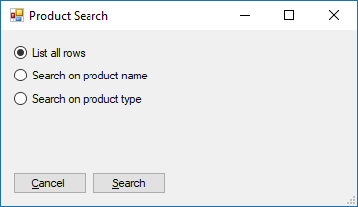

### Form Components

|  |  |  |  |  |
| --- | --- | --- | --- | --- |
| No. | Column Names | Control | Property | Value |
| 1 | rdoAll | RadioButton | Text | List all rows |
| 2 | rdoProductName | RadioButton | Text | Search on Product Name |
| 3 | rdoProductType | RadioButton | Text | Search on Product Type |
| 4 | txtSearch | TextBox |  |  |
| 5 | cmbProductType | ComboBox |  |  |
| 7 | btnSearch | Button | Text | &Search: |
| 8 | btnCancel | Button | Text | &Cancel: |

### Events Used on the form.

|  |  |  |
| --- | --- | --- |
| Component Name | Event | Description |
| btnCancel | Click | Cancel Search attempt |
| btnSearch | Click | Set search and return to list View |
|  |  |  |

### Form Name: frmSalesSearch

### Form Description: Sales Search Screen

### Form:

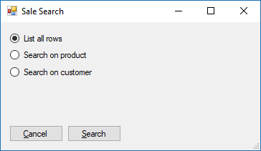

### Form Components

|  |  |  |  |  |
| --- | --- | --- | --- | --- |
| No. | Column Names | Control | Property | Value |
| 1 | rdoAll | RadioButton | Text | List all rows |
| 2 | rdoProduct | RadioButton | Text | Search on Product |
| 3 | rdoCustomer | RadioButton | Text | Search on Customer |
| 4 | cmbProductName | ComboBox |  |  |
| 5 | cmbSaleType | ComboBox |  |  |
| 7 | btnSearch | Button | Text | &Search: |
| 8 | btnCancel | Button | Text | &Cancel: |

### Events Used on the form.

|  |  |  |
| --- | --- | --- |
| Component Name | Event | Description |
| btnCancel | Click | Cancel Search attempt |
| btnSearch | Click | Set search and return to list View |
|  |  |  |

## Approval

Name: _____________________________ Date: ___/___/______